**GAME DESIGN**

**Game Name:** Dragonbones/The Old War

**Game Style:** RTS with some dungeon crawler

**Environment:** Dark fantasy

**6 LEVELS OF PROGRESS:**

* Not started
* Concept
* Basic
* Intermediate
* Complete
* Perfect

**PROGRESS SO FAR**

* Game Building
* Characters
* Story
* Environment
* Map
* Website

**Tech Overview**

* **Website:** Bootstrap Template/HTML
* **Game Engine:** Unity 3d
* **Scripting:** C#
* **Character Building**: Blender
* **Character Animation:** Blender
* **Mapping**: Inkarnate

**The Website**

* <https://kevinscampaigns.github.io/index.html>

**Crunch**

* Game logic (coding)
* Game mechanics (balance/techtree)
* Terrain Building (setting/environment)
* Character/Building Modelling (units)
* Animation (units)
* Lighting (setting environment)
* Sound (setting environment)
* World Map (setting environment)

**Fluff**

* Story Line
* Individual Events
* Factions
* Characters
* Races
* Locations
* Dark Medieval Fantasy

**Influences:**

Morrowind - Adventure

Skyrim - Epicness/Atmosphere

Warcraft 1/2 - Feel/Seriousness

Diablo – Dark/Action

Rise and Fall - Gameplay

**The Game World**

**The Provinces and World Map:**

**Ruun Province**

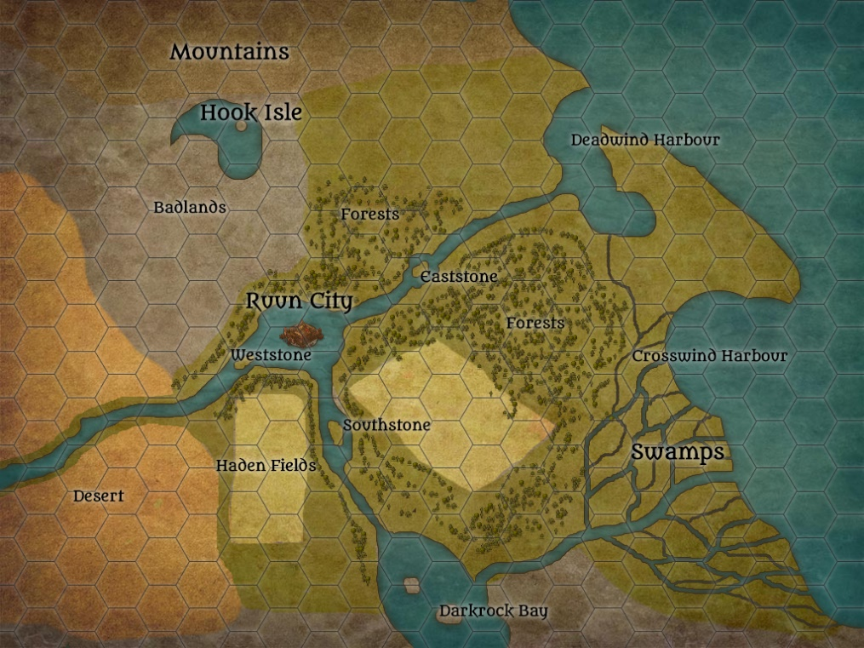

**Andon Province**

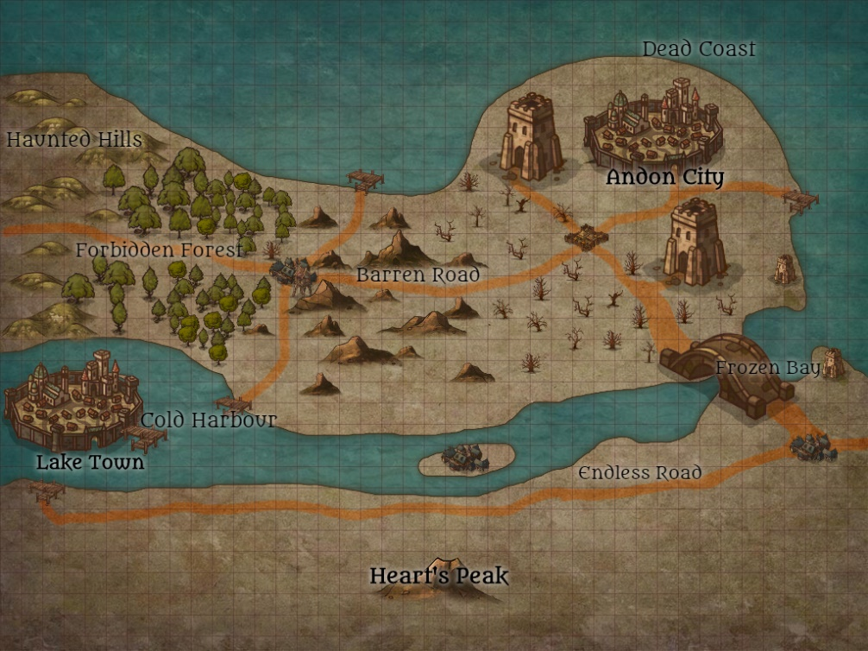

**Hindegarde**

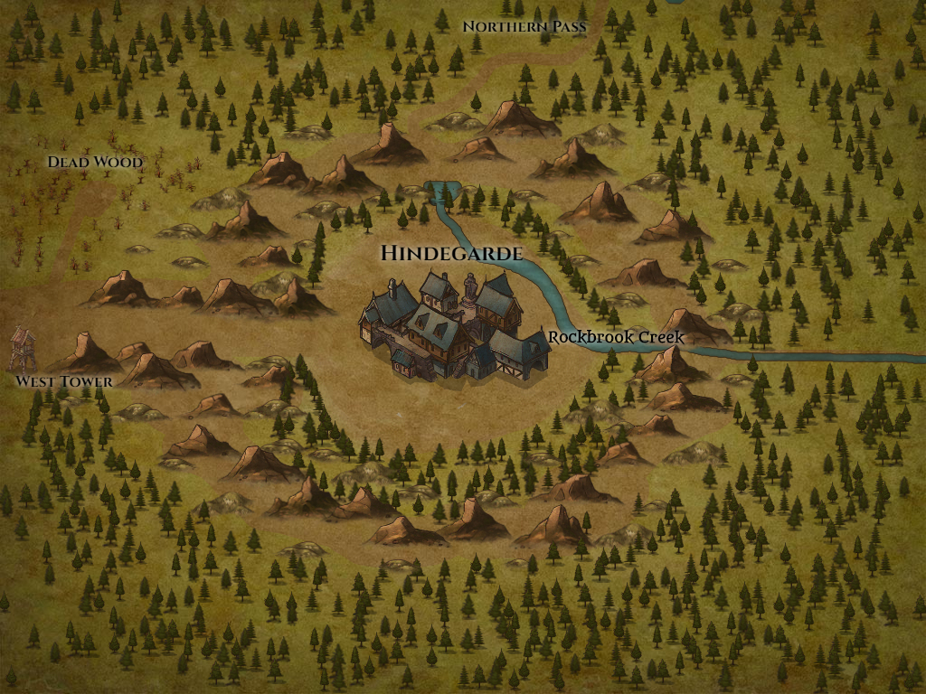

**Factions:**

**Kingdom of Andar (Medieval Humans) – Good**

* Playstyle
  + Standard base building
  + Require diverse resources
  + Require forward bases
  + Require good scouting

**Kingdom of Andar Build Order:**

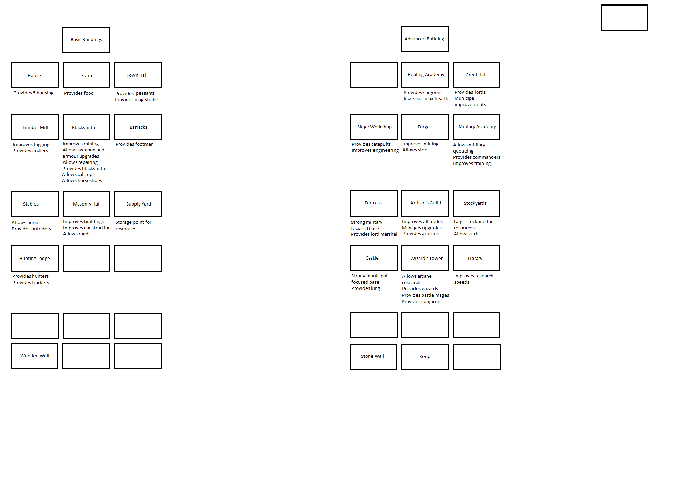

**Undead Legion (Roman Undead) – Neutral**

* Playstyle
  + Medium base building
  + Require bones/bodies/magic
  + Minimal scouting but many cheap, slow units

**Beastmen (Druids) - Good**

* Playstyle
  + Minimal base building
  + Plant trees/harvest/hunt/fish/protect & raise stones
  + Animal scouts, very fast, can shapeshift and teleport between stones

**Demons (Small Incursions) - Evil**

* Playstyle
  + No base building
  + Harvest/use souls as main currency/abilities
  + Can sense enemies long distance

**Little Folk (Hobbits) - Neutral**

* Playstyle
  + Maximum base building
  + Trade in every resource
  + Hire mercenaries

**Marauders (Slave Trading Humans) – Evil**

* Playstyle
  + Medium base building
  + Require people as slaves

**Secondary Factions:**

Orcs

Gutter Elves

Tinkerers

Towns

**Major Gameplay Mechanics:**

**Factions**

* 6 different factions
* Ton of different resources – different faction needs
* Skymetal – random element
* Faction movement drastically different
* Neutral factions and towns

**Environment**

* Day/night cycle – heavily impacts game
* Weather - Storms/Snow

**Gameplay**

* Injury mechanic
* Healing
* Take slaves
* Fast paced
* Several battles per game
* Diablo mechanic requiring command points